Software Development Methodologies – Agile vs. Traditional
Daniel M Beck
UMGC – SDEV-360
June 23, 2020

Software Development Methodologies – Agile vs. Traditional
With any current software development or maintaining of software, one will find a Software Development Life Cycle (SDLC) process that fits the specific needs of the project. Being in the job market, experience with the Agile methodology is one of the most sought-after qualities that companies are looking for in a candidate. Furthermore, since the Agile methodology was born from the Traditional methodology, it would be beneficial to gain a better understanding of both.

Overview of Traditional Method
Overview of the two to be compared Traditional software development methodologies include the Spiral model, V-Model and RUP. Methodologies like these “are based on a sequential series of steps like requirements definition, solution building, testing and deployment” (Leau, Y. B., Loo, W. K., Tham, W. Y., & Tan, S. F., 2012). One of the most common traditional methods is the waterfall method, which is a sequential, linear process “that consists of several discrete phases. No phase begins until the prior phase is complete, and each phase’s completion is terminal—waterfall management does not allow you to return to a previous phase. The only way to revisit a phase is to start over at phase one” (What the Waterfall Project Management Methodology Can (and Can't) Do for You, 2018). This model consists of six phases including:
Waterfall Method Phases
Waterfall Phase | Details
Requirements gathering and documentation | During this phase, the necessary information for the project is collected from the client. With this information, project requirements are formed and passed to all individuals in the team.
System Design | Based on the requirements, the team designs the system. Items such as what hardware is going to be used and programming language are decided.
Implementation | During this phase, the programmers take the requirements from the previous stages and build a functional product.
Testing | Once a functional product is built, testing begins to find any bugs or major concerns with the design. At this point, if there are any major problems with the design, the project may need to revert to phase one and be reevaluated.
Delivery & Deployment | After the product is programmed and tested for bugs by the team, the project is set to be released to the client.
Maintenance | After being released, the client may find bugs that require patches to fix. If the product is not what the client desired, there may be a need to start back at phase one.

Advantages and Disadvantages of Waterfall Method
There are multiple advantages to using this model. Since the Waterfall model follows the same sequential pattern for each project, it is easy for the team to use and understand. The Waterfall model is seen as rigid making each phase have specific deliverables making it easy to manage and control. Since every phase has a start and end point, sharing progress with product owners and customers is more accessible. There is less of a chance for a team to miss a deadline since the requirements and design are established before writing code. Typical Waterfall models are documented well throughout every phase. This results in better understanding of the logic behind the code and tests.
One of the main disadvantages of the Waterfall model is the complication that comes with any change. Once the team completes a phase, the only way to go back would be to start from the beginning. The time that the product takes to be deliverable is longer than with the Scrum method. Typically, coding starts later in the cycle so product owners will not get a chance to review the product until the product is almost completed. Gathering accurate requirements can become challenging. “One of the first phases in a Waterfall project is to talk to customers and stakeholders and identify their requirements. However, it can be difficult to pinpoint exactly what they want this early in the project” (What's the Difference? Agile vs Scrum vs Waterfall vs Kanban).

Overview of Agile Method
Agile software development methodologies which include the Dynamic Systems Development Method (DSDM), Feature-driven development, and Extreme programming (XP), are based on the idea of progressive and iterative development. Hence, the phases within the development life cycle are continuously reevaluated. This process regularly improves software by collecting customer feedback to gauge solutions and new features.
One of the most common agile methodologies is the Scrum Methodology which “is an agile project management methodology or framework used primarily for software development projects with the goal of delivering new software capability every 2-4 weeks” (What Is Scrum Methodology? 2020). The scrum typically consists team consists of the product owner, the development team of programmers, and a scrum master to oversee all the processes. Scrum teams are self-organizing and cross-functional. These teams find the most effective ways to accomplish their work without the direction of individuals from outside of their team. The Scrum team is organized to maximize flexibility, creativity, and productivity of the project. The processes of the Scrum model which repeats until the final product is accepted by the product owner, include:
Scrum Method Process
Scrum Process | Details
Product Backlog | A list of requirements for the final project is created.
Sprint Planning | The scrum team meets to decide what part of the product backlog to work on first.
Daily Scrum | After the project is set, the team meets daily to discuss the progress and any issues that have arisen. The scrum master ensures members of the team follow the theories, rules, and practices of the scrum.
Sprint Review | At the end of each sprint, there is a sprint review meeting that is organized by the product owner. During this meeting, the scrum team demonstrates what they have completed since the last sprint. The product owner then gives information about what items are remaining on the product backlog and estimated time to complete the project.
Sprint Retrospective | After the completion of sprint review, the scrum team assembles in a sprint retrospective meeting. During this meeting they discuss if any problems occurred and what improvements can be made for the next scrum cycle.
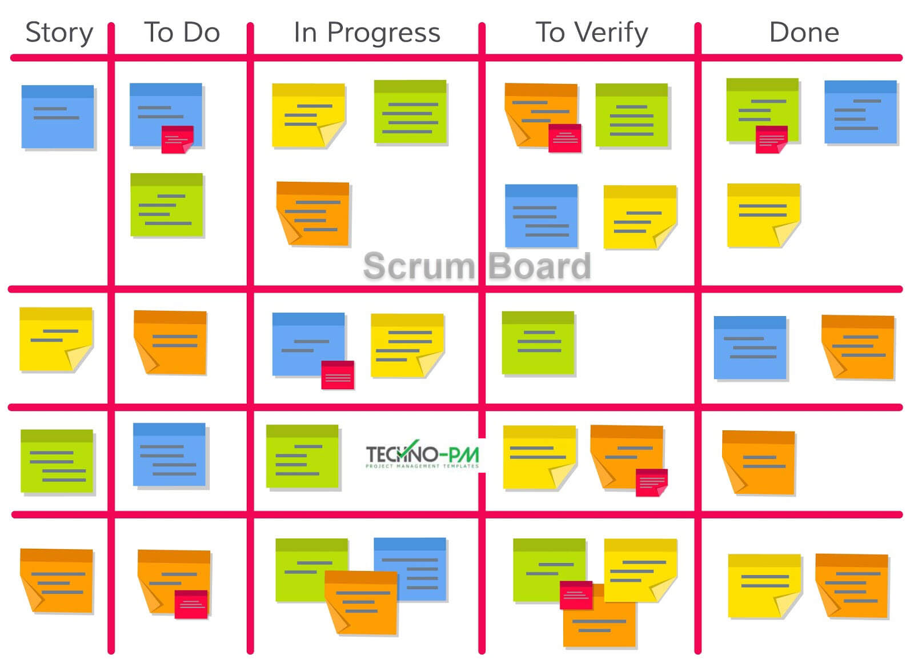
Figure 1, Wale, Scrum Board: 4 Templates and Examples
Many Scrum teams utilize Scrum boards that are used to track the progress of the sprints. As seen in figure 1, they can involve index cards, Post-it notes, or a whiteboard so that the team can easily update the board throughout the entire sprint. The Scrum board usually is divided into categories: story, to do, work in progress, to verify, and done.
In agile development, rather than a single large process model that is implemented in conventional SDLC, it is broken down into smaller phases which touch on the traditional processes of development. According to Agile Manifesto, the major factors that agile methods value are:
“Individuals and interactions over processes and tools
Working software over comprehensive documentation
Customer collaboration over contract negotiation
Responding to change over following a plan” (Beck, K., Beedle, M., Bennekum, A., Cockburn, A., 2001)

Advantages and Disadvantages of the Scrum Method.
For teams using the Scrum method comes many advantages. The use of daily stand-up meetings and the Scrum board keeps all the team informed and eliminates many misunderstandings and confusion. Since there is no project management telling the team works collectively to decide what to accomplish in each sprint. With the creation of sprints, and the constant feedback from users, changes can be made to the project fast and effectively. The constant communication amongst the team ensures the team is aware of all issues and changes as soon as they arise. This generates a higher quality product that is cost effective.
With the many advantages of Scrum come the disadvantages. Since there is no specific end date for many projects, there is a risk that the scope can creep. The product owner may want to keep adding features which can cause other projects to get pushed back. A Scrum team needs to be comprised of developers with experience because the roles are less defined. It would be difficult for someone with little to no experience to join a team and learn what needs to be done as other team members would be busy with their projects and unable to train them. If a task is inadequately defined or planned, there is a risk of increased project costs, missed deadlines or inaccurate functionality. The Scrum Master plays an important role in making sure this does not happen.

Conclusion.
Agile and traditional methodologies both still play an important role in software development today. The traditional method of Waterfall is applicable for software that needs to be fully functional and does not need to be updated regularly. An example of this type of project would be a banking application where all the features would need to be available at deployment. The agile method of Scrum is applicable for software that needs to be released quickly and gets updated regularly. An example of this type of project would be a video server such as Plex where many updates are pushed that add new features. These methodologies are important to have fundamental knowledge in when beginning a career in the software development field as they are the basis of a multitude of current projects today.

References
Beck, K., Beedle, M., Bennekum, A., &amp; Cockburn, A. (2001). Manifesto for Agile Software Development. Retrieved June 23, 2020, from https://agilemanifesto.org/iso/en/manifesto.html
Leau, Y. B., Loo, W. K., Tham, W. Y., & Tan, S. F. (2012). Software development life cycle AGILE vs traditional approaches. In International Conference on Information and Network Technology (Vol. 37, No. 1, pp. 162-167).
Wale, S. (n.d.). Scrum Board: 4 Templates and Examples. Retrieved June 23, 2020, from https://www.techno-pm.com/2017/05/scrum-board-example.html
What Is Scrum Methodology? (2020, February 16). Retrieved June 22, 2020, from https://resources.collab.net/agile-101/what-is-scrum
What's the Difference? Agile vs Scrum vs Waterfall vs Kanban. (n.d.). Retrieved June 23, 2020, from https://www.smartsheet.com/agile-vs-scrum-vs-waterfall-vs-kanban
What the Waterfall Project Management Methodology Can (and Can't) Do for You. (2018, September 05). Retrieved June 22, 2020, from https://www.lucidchart.com/blog/waterfall-project-management-methodology

